Do we have a Prudent Approach to End of Life Care?

This report represents formal advice from the Bevan Commission to the Minister for Health and Social Care. It is part of a wider programme of work being undertaken by the Bevan Commission.
The Bevan Commission
The Bevan Commission is a group of international experts to help ensure that Wales can draw on best practice from across the world while remaining true to the principles of the NHS as established by Aneurin Bevan. The Commission is not a formal part of the NHS in Wales and acts as an impartial advisory group to the Minister for Health and Social Services.
Current Bevan Commissioners
Professor Sir Mansel Aylward CB, Chair | Juliet Luporini
Nygaire Bevan | Professor Ewan Macdonald OBE
Professor Bim Bhowmick OBE DL | Chris Martin
Professor Dame Carol Black DBE | Professor Sir Michael Marmot
Dr Tony Calland MBE | Professor Andrew Morris
Sir Ian Carruthers OBE | Professor Sir Anthony Newman Taylor CBE
Mary Cowern | Dr Helen Paterson
Ruth Dineen | Professor Elizabeth Robb OBE
Dr Clare Gerada MBE | Professor Phillip Routledge OBE
Professor Trevor Jones CBE | Fran Targett OBE
Lt General Louis Lillywhite CB, MBE, OStJ | Sir Paul Williams OBE CStJ DL
Ann Lloyd CBE | Professor John Wyn Owen CB
Bevan Commission Staff
Helen Howson (Director, Bevan Commission and Bevan Academy, Consultant in Public Health), Sion Charles (Deputy Director) and Dr Tom Powell (Researcher).
Special Advisors
Current Special Advisors to the Bevan Commission are Professor Marcus Longley, Professor Donna Mead OBE, Professor Marc Clements and Professor Ceri Phillips.
Publications
Reports produced by the Bevan Commission are published on the Commission website at www.bevancommission.org.
Contact
All correspondence should be addressed to the Bevan Commission, 14 Cathedral Road, Cardiff, CF11 9LJ.

Background
Due to advances in medicine more and more people are living longer, healthier lives. As a result the phrase “quality of life” has become common parlance within healthcare and the benchmark by which we wish to evaluate the services that the NHS provides. Rarely however do we talk about providing a good “quality of death” or a good quality of life in the period leading to death.
While more and more people are living longer, they are doing so with the burden of long term chronic conditions creating challenges for those who deliver end of life (EoL) care.
Palliative care is often synonymous with those suffering from cancer where it is relatively easier to determine an individual’s prognosis. Conversely conditions such as cardiovascular disease, dementia or respiratory conditions are less predictable which can impact on the quality of EoL care received. It has been proposed that there are three distinct illness trajectories for people with a progressive chronic illness:
- A trajectory with steady progression and usually a clear terminal phase; mostly this relates to people with cancer.
- A trajectory with gradual decline, punctuated by episodes of acute deterioration and some recovery, with more sudden, seemingly unexpected death; for example, individuals with respiratory or heart failure.
- And a trajectory with prolonged gradual decline; typical of frail elderly people or people with dementia (Murray et al, 2005)
The provision of quality EoL care is an essential component of a modern health service. The UK is regarded to be leader in this area and in 2010 was ranked as number 1 in the world (EIU 2010). However, while this ranking suggests that the UK is a world leader, it does not mean that the service within the UK is perfect. Above all we should not lose sight of the fact that our ultimate goal is ‘not what is a good death but a good life to the very end ‘(Gawande 2014).
In Wales as in other parts of the world, the demand for good quality EoL and palliative care will continue to increase consistent with and aging population. The NHS in Wales, along with other public services together with those reaching the end of their lives, must be prepared to have more open conversations about their needs and wishes and meet the challenge of this increasing and sensitive responsibility together. As a result the Minister for Health & Social Services has asked the Bevan Commission to provide him with further advice on a achieving a more prudent approach to EoL care in Wales.

UK and Welsh Policy
One markers of a leading nation in this area is the acknowledgement at a national level of the importance of EoL care which can be frequently reflected in the provision of associated national policy. There have been many policy developments within the UK as a whole and also within Wales since 2008 which have produced a range of evidence and guidance around EoL care (Appendix 1).
There are many reoccurring themes throughout these policy documents and reports. The most recent Welsh Government EoL care annual report (2015) neatly summarises the priorities which need to be addressed as:
- Encouraging more people to have open and honest conversations about their EoL preferences and final wishes with family and friends, including refusal of treatment, supporting them to make a Will and lasting power of attorney.
- Supporting GPs to ensure that patients are being identified earlier as being in their last year of life.
- Ensuring that systems are in place that supports more people to be cared for and to die in the place of their choice.
- More information to be made available to help health and social care professionals and the public understand what palliative care is; when it can help and what the benefits are.
- All relevant health and social care professionals, including care home workers, should be trained and supported to help people think about their care and develop advance care plans.

Summary Statistics
There are a variety of sources that produce statistics relevant to EoL care in Wales (Figure 1) and with the way in which official statistics are produced varying by time period or geographical coverage, makes comparison and inference difficult.
In Wales the main causes of death are Circulatory Disease, Cancer and Respiratory Disease however in England, Wales and Northern Ireland in 2012-13 88% of palliative care inpatients and 75% of new referrals to hospital support and outpatient services were for people with a cancer diagnosis (Dixon et al 2015). This suggests that patients with a cancer diagnosis are much more likely to receive EoL care.
Data from the VOICES bereavement survey in England suggests that the majority of people who say where they would like to die, express a preference to die at home (79%), but only half of people who want to die at home actually die there. One third of people (35%) who want to die at home in England actually die in hospital (ONS 2014). In Wales the majority of people die in hospital (ONS 2015).
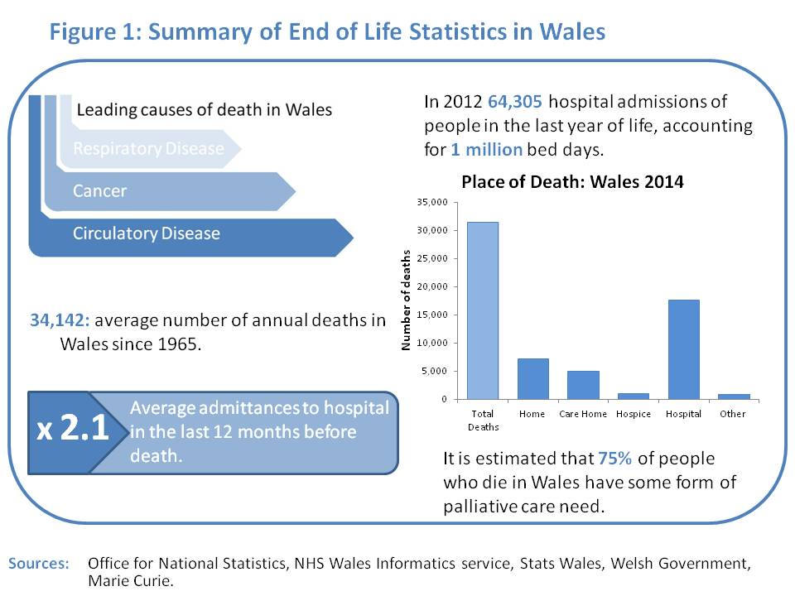

Factors influencing end of life care
There are many different practical barriers that prevent good EoL care which have been reviewed in a range of publications and have summarised in Figure 2. This suggests that experiencing any factor that contributes to poor EoL care (those in Red in the model) can inhibit those factors that promote good EoL care. 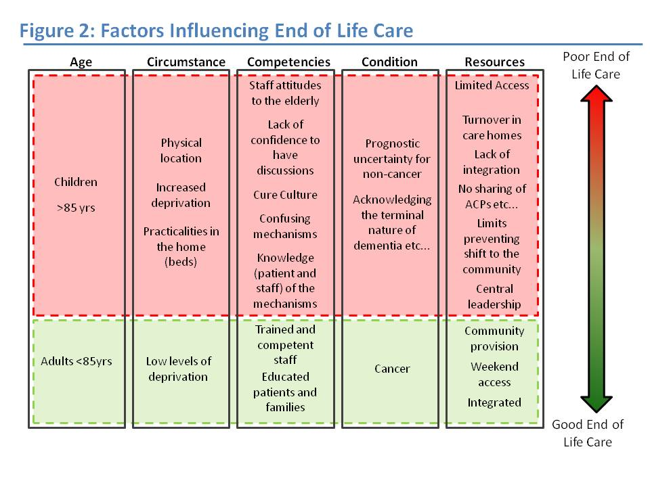

End of Life care though a prudent lens
The Commission held an evidence gathering session in November 2015 with invited experts from across the NHS, Welsh Government, Academia and the Third Sector to discuss EoL care in the context of the 4 Prudent Principles. (Attendee list can be found in Appendix 2). The following key points were highlighted;

Prudent Principle 1: Achieve health and well being with the public, patients and professionals as equal partners through co-production
- We need to engage more fully with patients, their families and carers in a way that they can understand and that they feel comfortable with, consistently across Wales.
- Care of the dying should be a core generic staff skill and not just left to those working in palliative care. We need a culture shift towards a more compassionate approach based upon ‘Is it good enough for my Mum or Dad?’
- Patients should be supported to express what they really want and, along with carers and families, should be involved in co designing and co delivering services including bereavement services. Carers and health and social care professionals should take into account their wishes or refusals for any future care.

Prudent Principle 2: Care for those with the greatest health need first, making the most effective use of all skills and resources
- As individuals vary, so does the way in which they approach the end of their lives. For some patients they will have the time think about their wishes and plan for the future. For other patients the end of life is much more immediate and time critical where decisions have to be made quickly. That such differences exist must be recognised by care providers.
- Greater involvement with Nursing and Care home staff is needed to help and support the embedding of core EoL skills. Encouragement of stronger networks across organisations and services with greater access into care homes.
- Better integration and joined up working between all key partners across health and social care and the third sector. Embedding good end of life care within GP clusters and locality teams is a major priority.
- Recognising what services and support are currently available and where there may be gaps or breaks in the continuity of EoL care. Accurately mapping available care across the NHS and third sector provision.
- Effective use of current undergraduate training to strengthen skills at all levels. Education commissioners in Wales should use their influence to insist on the inclusion of EoL care within or additionally to the existing professional’s curricular.
- All health professionals should be able to undertake EoL training as part of CPD/ CE programmes.
- All Carers should be offered support and training.

Principle 3: Do only what is needed, no more, no less; and do no harm
- Professional capacity, sound clinical judgement, with rapid diagnostic pathways is essential to promote good EoL care.
- All Staff should feel comfortable and able to ask for help when unsure of what to do.
- Patients and their carers should have a single point of contact through EoL care so that changes can be made quickly in the care being received.
- Strengthening knowledge and skills of EoL in A&E units and with paramedics whilst ensuring access to palliative care expertise to prevent and manage unscheduled attendance and unwarranted treatment, visits/stays in hospital.
- All healthcare professionals must have access to specialist palliative care support and advice.

Principle 4: Reduce inappropriate variation using evidence based practices consistently and transparently
- Good EoL care should be based on a principle of fairness of access and where differences occur this should be openly shared.
- Core training requirements need to ensure the equity of training provision across Wales.
- We need to strengthen and support managed risk in EoL as there appears to be a trend of ‘Risk Averse Practice’ – a culture of fear of being blamed for causing the death of a dying person.
- A duty to recognise and treat distress.
- All out of hours services should carry pain relief drugs and other support needed to respond in a timely and appropriate manner.
- All Out of Hours services should be able to access patients’ notes to provide continuity of care.
- Palliative care registers in primary care should be fully employed and the patient’s wishes clearly recorded and available to all concerned.
Practical examples applied to EoL
- Early conversations with individuals diagnosed with a terminal illness & referring to appropriate agencies would minimise distress and inappropriate admissions.
- GPs report that the availability & access to subcutaneous fluids is sometimes difficult and as a result admission to hospital is the only choice even if the patient would have preferred to stay home.
- The lack of discharge letters means patients are being admitted unnecessarily as GPs are finding it hard to work out whether they should treat or not treat. Discharge planning redesign would benefit from an all Wales approach.

Achieving a Prudent approach to End of Life care in Wales
Much of the evidence gathered for this work was obtained through surveys, stories and recollections of individual’s experiences of EoL care, often for loved ones or for those they have cared for. This, along with our other evidence has clearly told us that whilst EoL care or palliative care in Wales has seen significant improvement over the last decade, it is not prudent and does not yet fully reflect the four prudent healthcare principles. This can be illustrated as follows, where;
- real conversations have not been held or the voice of the patient is just not heard;
- care is often fragmented and repetitive, overwhelmed by rules, regulations and systems;
- risk is avoided not actively managed;
- decisions are not in the patients interest and where common sense seems lost;
- the simple solutions and personal priorities are often missed or overlooked resulting in more complex medical solutions or unnecessary invasive treatments;
- both staff and patients are not well equipped to deal with often sensitive and distressing conversations;
In order to help address these factors we have identified a number of important elements:

Everyone’s business
EoL care is not seen sufficiently as a priority and where it is, it is often seen as just the responsibility of Palliative Care specialists and particularly related to cancer care. EoL should be everybody’s responsibility. It should be the responsibility of all care givers, including families, friends and wider informal carers in the community as well as formal carers in health and social care settings. EoL should be routinely planned and provided for within day to day work and general care, supported by training and more specialised trained staff as and when needed.
Greater control (with support and training) should be given to front line care givers. Continuity of care with familiar faces is important to patients, being able to talk and with people who understand them, their needs and everyday circumstances. Often just having someone knowledgeable and experienced with the time to talk, allows opportunistic conversations, by those who are known and trusted, can make all the difference. We need to provide training and support to help and equip carers to deliver this.

Talk with and Listen to patients and those with them
The need to talk to and listen to the patient and what they are saying should not be underestimated. It can have significant ramifications for the quality of life during the last days of life. Co-producing the delivery of EoL care is essential, as is using the assets of patients, families, third sector and professionals as advocates for the dying. Atula Gawande (Gawande 2014) describes how discussions with patients led them to be less likely to have invasive treatment, enrolled at a hospice, suffered less, incurred less cost and were more able to interact with other people; in other words they were more likely to die at peace and in control. This in turn will help families come to terms with their grief or loss and be better equipped to cope We need to value these discussions and find better ways to support and enable these, listening to and being able to be flexible to respond to what patients are saying. Skilling and empowering staff to do this will be important.

Confidence in actively managing risk
As care for the frail elderly becomes more complex and challenging within a society which often looks for someone to blame, there is a greater tendency towards more risk adverse behaviours among health professionals which often results in increased inappropriate admissions to hospital. EoL is not a precise medicine and whilst guidance and protocols will help, they rarely have the precise answer for individual circumstances and where judgement must be used.
We must find ways to empower and support staff, encouraging better management of risk. This could include the provision of some health care services within the home, co producing and working through solutions with the patients’ to meet their needs and interests and supported by the system and professionals. Effective and prudent risk management should also be reflected within audit and inspection processes.

Skills and training
Equipping professionals, patients and carers with the necessary skills to support EoL is essential to enable better conversations and more effective communication between them on the specific needs and wishes of the patients. Attracting and developing a workforce for the future with skills in EoL care in a sensitive and appropriate manner has featured throughout our work. It has reinforced the need for care of the dying to be included as a generic skill for all health professionals, as well as up skilling GP’s , nurses and others working within the community to ensure 24 / 7 care is covered. Undergraduate, postgraduate and in-house training across a range of health professions, other care providers and informal carers is needed. Further opportunities to address better and more consistent end of life care across Wales should be explored within QoF and GP enhanced services and through mandatory continuing professional development.
Nursing home staff and domiciliary care workers also need support to enable informed conversations and a positive culture change towards EoL care. This should also involve encouraging additional skills, qualifications and responsibilities to ensure they are fully able to play their part for the people who live within their own homes. The regulatory and educational bodies should also recognise this and include prudent EoL care as a core component of their curricula, inspection and assessment processes.
Geriatricians and palliative care specialists should be reflected within the context of increased need and associated recruitment. Incentives to attract staff such as R&D opportunities or more flexible working practices between the community and the hospital, working alongside GPs and across care homes and hospices should be adopted.

Integration - whole systems working and communicating
Whilst some progress is being made there is still a lack of integration, communication and joined up working across professional and organisational boundaries, with the third sector, the wider community and civil society as a whole. Much better integrated working and communication is needed between hospitals, (acute and specialised care) care provided by geriatricians, palliative care consultants, primary care and voluntary and community based services and support, hospices and nursing homes. They all need to work much more closely together to make best use of all the skills and resources available including family and friends based upon the needs of the patient as the overriding factor. Patients in end of life and their families often have to find their way between and across a plethora of services and systems on top of dealing with their physical and emotional needs. It is often made it unnecessarily hard and complex to deal with, often overly medicalised and with little continuity or coordination.
There is a need to strengthen communication, understanding, skills and support in EoL care particularly within and between A&E, Out of Hours, Nursing homes, GP practices and GP clusters, and Community Resource Teams to ensure 24/7 care is made possible and all skills are appropriately used including that of family and friends. A prerequisite of this will be the ability to make data sharing a reality across the board.
Nursing homes will be a vital component in managing and supporting EoL care in the future. This will need to be underpinned by a clear integrated support system, developed skills and competencies, mindful of respect and dignity in caring for older people at the end of life. Opportunities to learn from schemes such as the Welsh Governments’ Team Around the Family initiative, applied to Team around EOL, may also be helpful in supporting better integrated working.

Variation
Greater emphasis is needed on EoL care in non cancer patients to avoid the discrepancies that currently exist, particularly with children. The ability to share and exchange relevant health and social care data in an easy and timely fashion is an essential prerequisite in ensuring that variation in EoL care is properly addressed. Including the patient view and perspective is also important and using patient stories and feedback should form an essential part to promote the adoption of good practice consistently across Wales. The Betsi Cadwalader Hospice at Home scheme and other such schemes should help provide the means for sharing learning and ensure the widespread adoption of more innovative practice and improved outcomes for patents, within all GP clusters / localities.

Easy systems and processes
Too often accessing the right EoL care is made unnecessarily difficult and complex. Whether forms, systems, processes, or other barriers are put in the way, making what is already a difficult job even harder. There is a need to take understand these, working with and listening to patients and carers to help find innovative ways to refine and overcome them. Simplified processes following refusals, wishes and plans should be developed for use across Wales. A simple but safe system to help people have conversations and to help them make the difficult decisions, such as Advanced Decisions to Refuse Treatment (ADRT) is needed.

Planning and Provision
Increased numbers of frail elderly with complex needs, requires more complex care. This population is already identifiable with approximately 40 – 50% in hospital, 30% in care homes, 10% in hospices and 15 % at home at the moment. Some people may wish to die at home but are unable to do so because they live alone. The provision of services such as hospice at home and third sector support should be explored further as a part of a package of flexible support services to suit different circumstances. There is a clear need to use the data available, service mapping and modelling techniques and the public, to proactively plan and prepare for the provision this across health and social care services in the future, A more strategic and less haphazard approach is needed.

In Summary
If, as it appears, we do not currently have a prudent approach to EoL care in Wales action must be taken to address this. There are some positive moves in Wales but these are all at varying stages of development and still very much in their infancy. There is much more to be done.
This paper has identified a number of ways in which we can continue to make improvements, but we must first overcome the barriers to change and a culture of complacency. We must proactively share the common goal of not what is a good death, but what is a good life – to the very end and remembering that this will be different for every individual. It may or may not require medical interventions but without good open conversations this can easily be missed or overlooked. Making time for these conversations, using a range of people and means of communication is really important. Most recently Mark Tauber, a Bevan Commission Exemplar, used an open letter to David Bowie following his death as a means to help discussions with his patients around their own death, which engaged millions across the world in the conversation around death and dying.
We must learn from this and have the courage to use different means to help stimulate and drive change, particularly in culture and attitude, recognising that many people may have other priorities beyond just being safe and living longer --- by sustaining the meaning in life for them. We lose sight of this at our peril and maybe the most vivid reminder of this would be the simple slogan -- ‘Is it good enough for your Mum or Dad?’
Together we must find the courage to do what is right, even in the face of adversity ‘Courage is strength in the face of what is to be feared or hoped. -- Wisdom is prudent strength’ (Gawande 2014).

Recommendations
- Identify an EoL champion in each Health Board to help drive and support the cultural changes needed and particularly to ensure better understanding, coordination and continuity of care promoting open conversations about choices and a good life to the end.
- Take more positive action and practical steps to help people die at home amongst family and friends working with patients and families to find the best solutions for them.
- Work with patients, carers and families to co develop appropriate training and support for patients and their families and the wider network of carers in the community.
- Embed EoL training throughout undergraduate and post graduate training for professionals as well as for nursing home and home carers.
- Share and adopt good practice across all areas of Wales to ensure consistently good care everywhere.

References
Dixon, J, King, D, Matosevic, T, Clark, M and Knapp, M (2015)Equity in the provision of palliative care in the UK: review of evidence. Discussion Papers, 2894. London School of Economics and Political Science, Personal Social Services Research Unit, London, UK.
Economist Intelligence Unit (2010) The quality of death: Ranking wins of life care across the world. The Economist.
Gawande, A (2014) Being Mortal: Medicine and What Matters in the End. Profile Books. USA
Murray SA1, Kendall M, Boyd K & Sheikh A. (2005) Illness trajectories and palliative care. British medical Journal ;330(7498):1007-11.
ONS (2014) National Survey of Bereaved People (VOICES) 2013 http://www.ons.gov.uk/ons/rel/subnational-health1/national-survey-of-bereaved-people--voices-/2013/stb---national-survey-of-bereaved-people--voices-.html
ONS (2015) Deaths Registered in England and Wales, 2014 http://www.ons.gov.uk/ons/rel/vsob1/death-reg-sum-tables/2014/sb-deaths-first-release--2014.html
Welsh Government (2015) Together for Health End of Life Care Delivery Plan: Annual report 2015.

Appendix 1
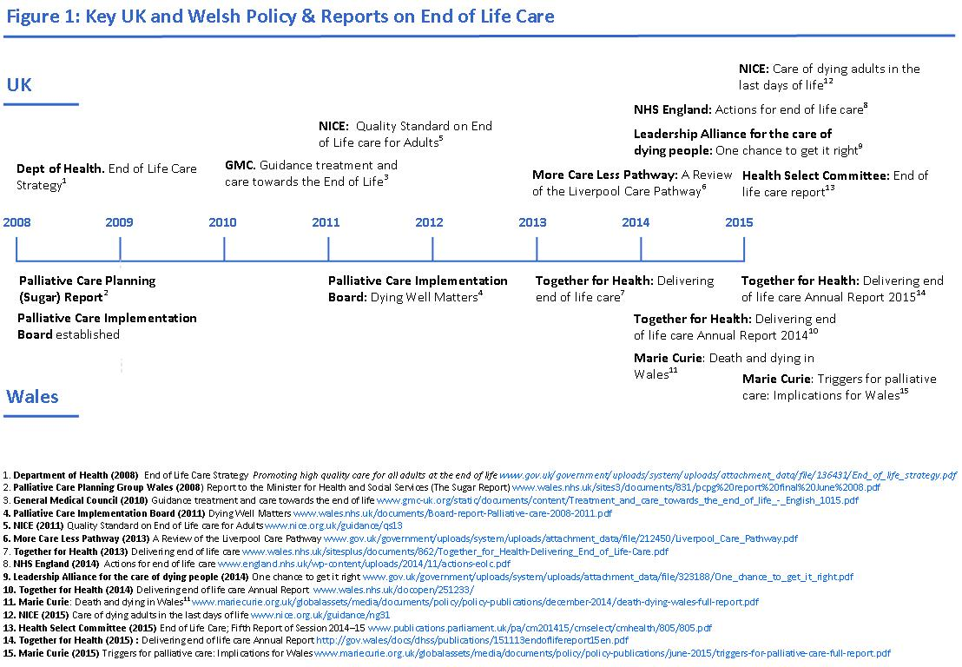

Appendix 2 : Task & Finish Group Members

Chris Martin (Chair)
Bevan Commissioner
Baroness Ilora Finaly
Daisy Cole,
Director of Wellbeing and Empowerment, Older Peoples Commissioner for Wales
Dr Rhian Morse (Cardiff and Vale UHB - General Medicine)
Theresa Richards
Bevan Commission Exemplar Betsi Cadwalader UHB
Dr Tessa Watts
Associate Professor Nursing Swansea University
Janette Bourne,
CEO of Cruse Cymru
Sir Paul Williams Bevan Commissioner
Helen Howson Director Bevan Commission
Tom Powell Researcher Bevan Commission
Sania Munir Senior Project Officer Bevan Commission

